**Delhi Institute Of Engineering & Technology**

TO WHOM IT MAY CONCERN



This is certify that Jeevan Kumar Roll NO. 1649810017 , Chandan kumar Roll no. 1649810011 , Meraj Alam Roll no 1649810018 (4th year) has submitted his PROJECT REPORT Diet E-Mentance App duly signed by the H.O.D CSE . PROJECT REPORT is accepted for evaluation.

Mr. Nitin kumar Kansal Sir Mr. Parveen Sir

(H.O.D of CSE) (Assistant Professor of CSE)

***Diet E-Mentance App***

ACKNOWLEDGEMENT

The satisfaction that accompanies the successful started Of any task would be incomplete Without the mention the names Of people whose ceaseless cooperation made it possible, whose constant guidance and encouragement crown all efforts With success.

I Offer my sincere thanks to Mr. Parveen kumar Sir Lecturar (B.tech), Delhi Institute Of Engineering & Technology (DIET),

I am thankful to Mr. Nitin kumar Sir for giving me an opportunity to work **Diet E-Mentance App**

under his guidance, inspiration and constructive suggestion that helped me in the preparation and execution of the manuscript, as part of the seven semester project training Of B.tech curriculum.

PREFACE

•*This project report is submitted for the partial fulfillment Of B.tech from Diet Meerut, This project is a* ***Diet E-Mentance App*** *which mentance the all diet institute*  *simple project developed using Python. The project contains only the admin side. It is an integrated console-based application that handles various academic activities of a College.*

**Diet E-Mentance App**

***Introduction:***

The project contains only the admin side. It is an integrated console-based application that handles various academic activities of a College.

#### ****About system :****

#### Talking about the system, it contains only the admin section. This project is made using the Tkinter module and used sqlite3. Also, the system has a simple design so that the user won’t get any difficulties while working on it.

* Menu: A Menu page that helps in easy access to other segments.
* Student Profile: Over here we can see all the general pieces of information related to students. Furthermore, we can add, remove, and update the information.
* Library Management System: In this window, we can see all the issued book-related details. It additionally provides a book issue feature where we can check all the present books and issue them.
* Marksheet: Over here we can search students’ mark sheets via roll number and also we can instantly add a new mark sheet too into the local database.

Moreover, this is a simple GUI-base project which is very easy to understand and use.

Objective:

* To handles various academic activities of a College.
* Over here we can see all the general pieces of information related to students.
* Likes we can add, remove, and update the information.
* To see all the issued book-related details. It additionally provides a book issue feature where we can check all the present books
* we can search students’ mark sheets via roll number and also we can instantly add a new mark sheet

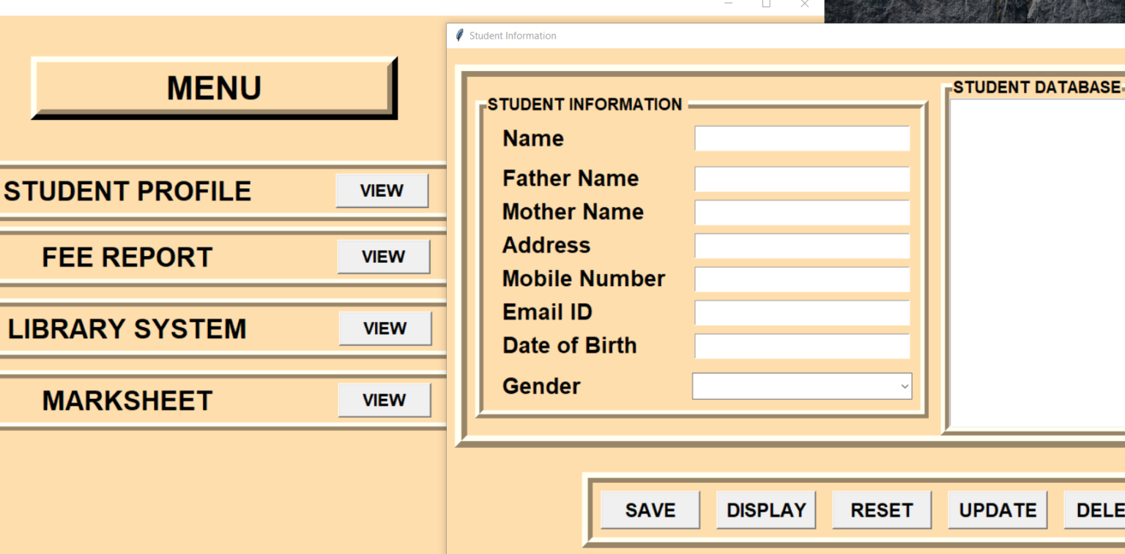

#### Student Profile:

#### 

#### Over here we can see all the general pieces of information related to students. Furthermore, we can add, remove, and update the information.

Objective:

* To handles various academic activities of a College.
* Over here we can see all the general pieces of information related to students.
* Likes we can add, remove, and update the information.
* To see all the issued book-related details. It additionally provides a book issue feature where we can check all the present books
* we can search students’ mark sheets via roll number and also we can instantly add a new mark sheet

#### Fee Report:

* *To check the students fee*
* *To update the students fee*
* *To search the students fee*
* *To print the receipt and much more…*

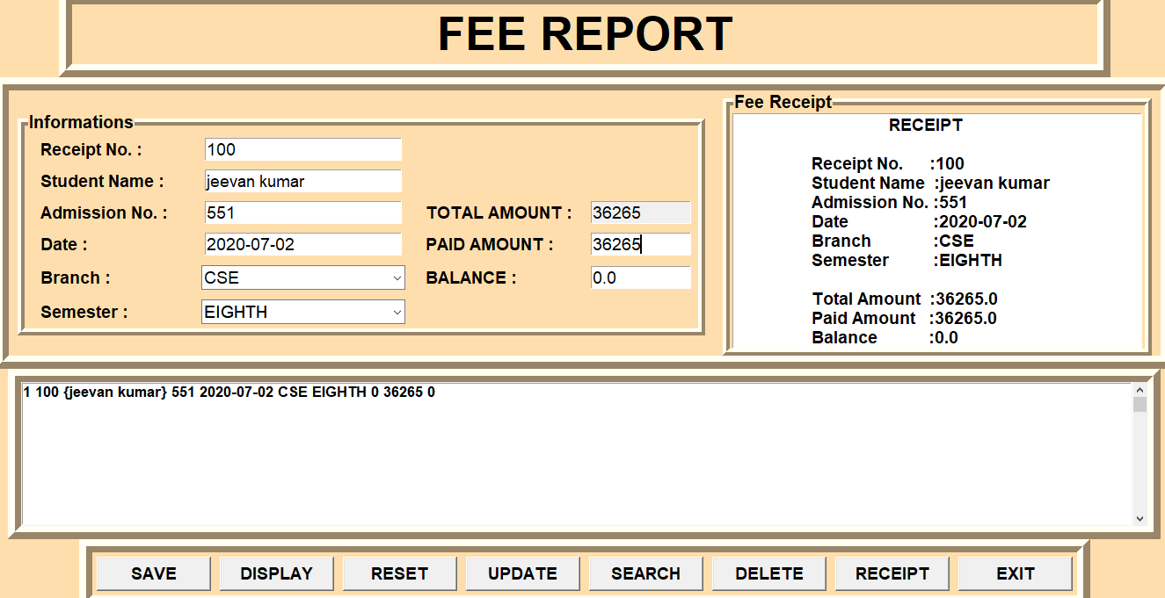*.*

Objective:

* To handles various academic activities of a College.
* Over here we can see all the general pieces of information related to students.
* Likes we can add, remove, and update the information.
* To see all the issued book-related details. It additionally provides a book issue feature where we can check all the present books
* we can search students’ mark sheets via roll number and also we can instantly add a new mark sheet

***Library System :***

Library Management System: In this window, we can see all the issued book-related details. It additionally provides a book issue feature where we can check all the present books and issue them.

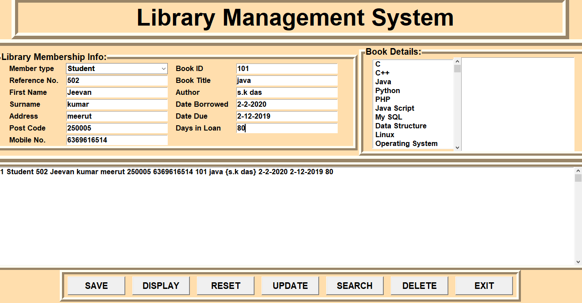

Objective:

* To handles various academic activities of a College.
* Over here we can see all the general pieces of information related to students.
* Likes we can add, remove, and update the information.
* To see all the issued book-related details. It additionally provides a book issue feature where we can check all the present books
* we can search students’ mark sheets via roll number and also we can instantly add a new mark sheet

**Marksheet :**

Marksheet: Over here we can search students’ mark sheets via roll number and also we can instantly add a new mark sheet too into the local database.

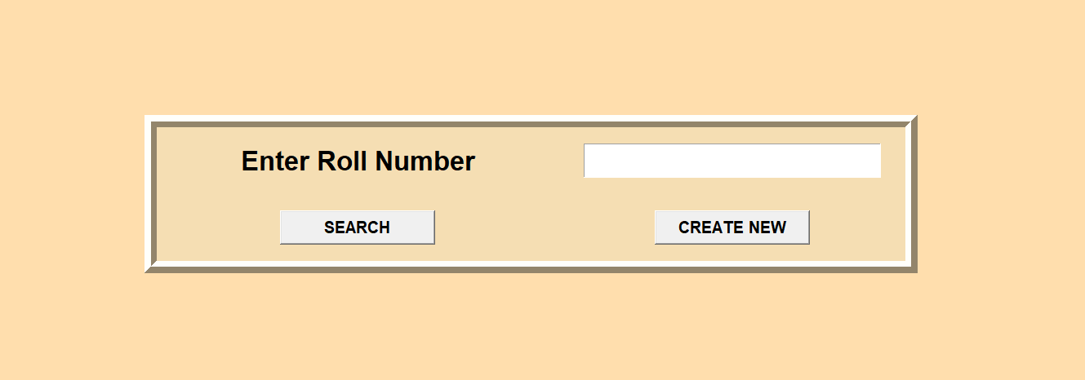

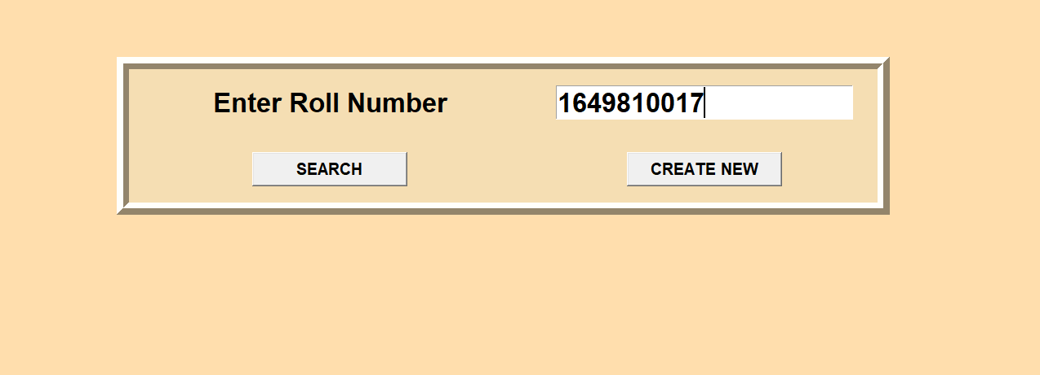

Here to Create New Roll Number :

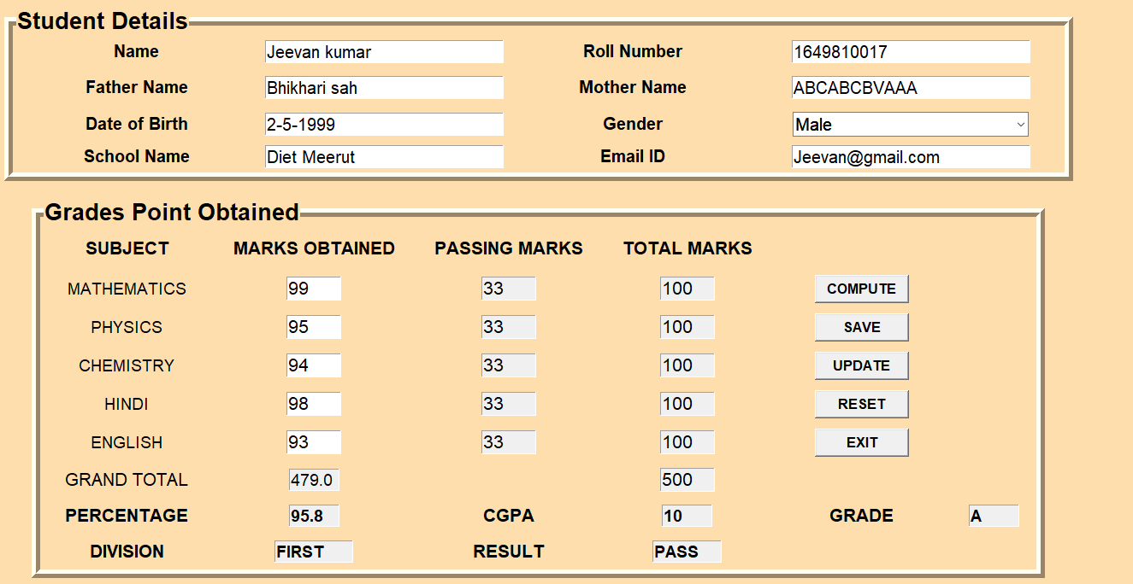

Objective:

* To handles various academic activities of a College.
* Over here we can see all the general pieces of information related to students.
* Likes we can add, remove, and update the information.
* To see all the issued book-related details. It additionally provides a book issue feature where we can check all the present books
* we can search students’ mark sheets via roll number and also we can instantly add a new mark sheet

***Advantages of Diet E-Mentance App :***

* ***To easy to manage all students records***
* ***To easy to use this app***
* ***Easy to mentanances***
* ***All information available in one app***
* ***To handles various academic activities of a College.***
* **The Menu page that helps in easy access to other segments.**
* **we can see all the general pieces of information related to students.**

FUTURE SCOPE OF THE PROJECT :

* ***To easy to manage all students records***
* ***To easy to use this app***
* ***Easy to mentanances***
* ***All information available in one app***

***CONCLUSION***

***During the training we learnt how to make a product is doesn't mean take raw material & just put it together and product is ready but it means that manufacturing a product is a systematic process which consist Of a Step by Step process for this purpose.***

***We learned the Steps involving in software development life cycle.***

***In the practical sessions we made the project assigned, on which we developed the design documents & made an analysis on how it can be developed.***

***At last, training period is a time, which really enables the trainee to develop his/her skills, gain knowledge that how, an organization works & now a product is manufactured With collective work Of so many people.***